Test Plan (Orange HRM)

# Table of Contents

* Test Plan 1
* Objective 2
* Scope 2
* Inclusions 3
* Test Environments 6
* Defect Reporting Procedure 7
* Test Strategy 8
* Test Schedule 8
* Test Deliverables 9
* Entry and Exit Criteria 9
  + Entry Criteria 9
  + Exit Criteria 9
* Test Execution 9
  + Entry Criteria 9
  + Exit Criteria 9
* Test Closure 9
  + Entry Criteria 9
  + Exit Criteria 9
* Tools 10
* Risks and Mitigations 10
* Approvals 10

# Objective

This document outlines the Test Plan for the **OrangeHRM** application.

The objective is to ensure that all key features and functionalities of OrangeHRM are tested thoroughly to deliver a robust, bug-free application ready for end-user adoption.

Technologies:

* PHP (Laravel Framework)
* JavaScript / jQuery
* MySQL Database
* Apache/Nginx Server

# Scope

The scope includes testing core modules such as:

* Login & Authentication
* Dashboard Widgets
* Employee Management
* Leave Management
* Time Tracking
* Recruitment
* Admin Settings

Types of Testing:

* Functional Testing (Manual)
* UI/UX Testing
* Regression Testing
* Smoke & Sanity Testing
* Compatibility Testing (Cross-browser, Cross-platform)
* Accessibility Testing

Testing Environments:

* Windows, MacOS, Linux
* Mobile OS (Android/iOS)
* Browsers: Chrome, Firefox, Safari, Edge

Success Evaluation:

* Zero Critical Defects
* High-priority defects fixed before release
* Functional completeness

Team Roles:

* Test Lead, Testers, Developers, DevOps

# Inclusions

This test plan covers:

* Login Page! 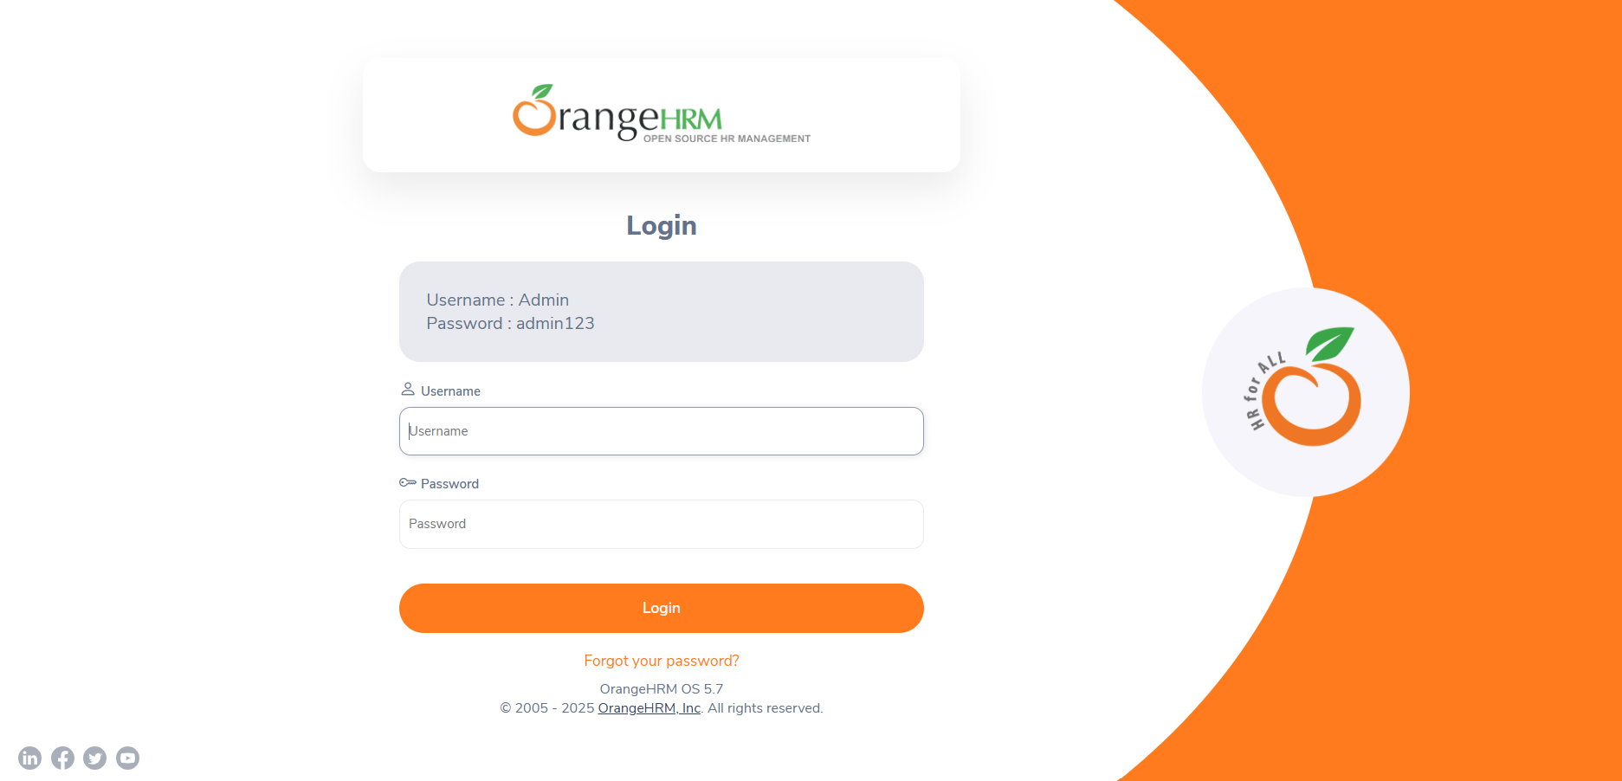
* Dashboard Page! 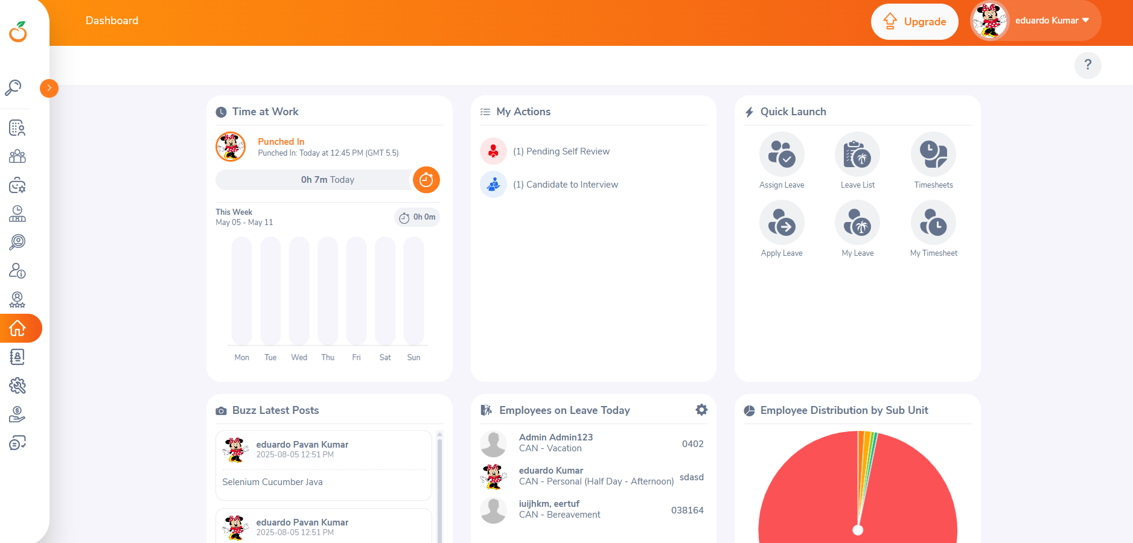
* Admin Module! 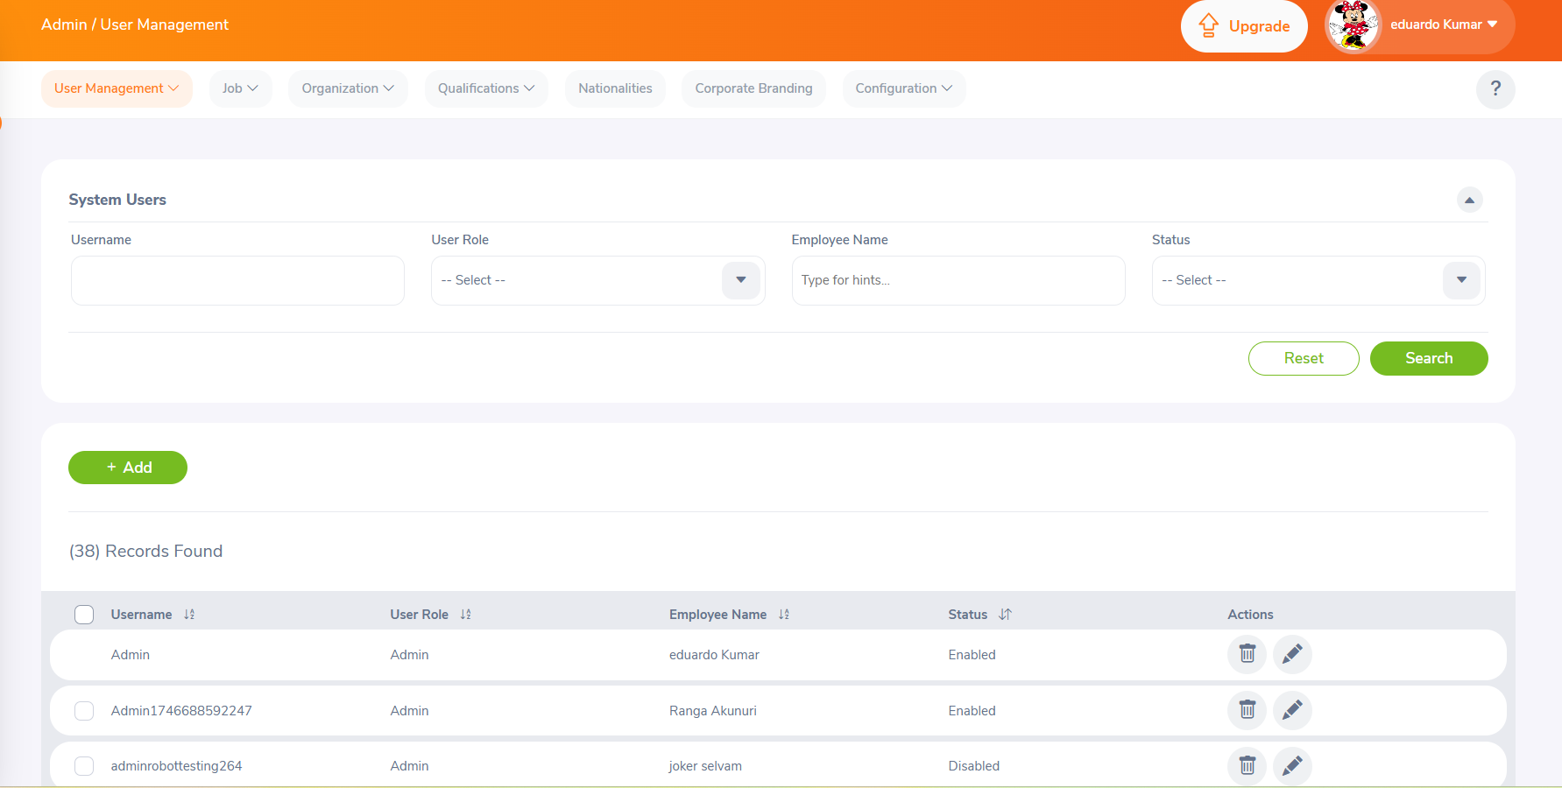
* Leave Module! 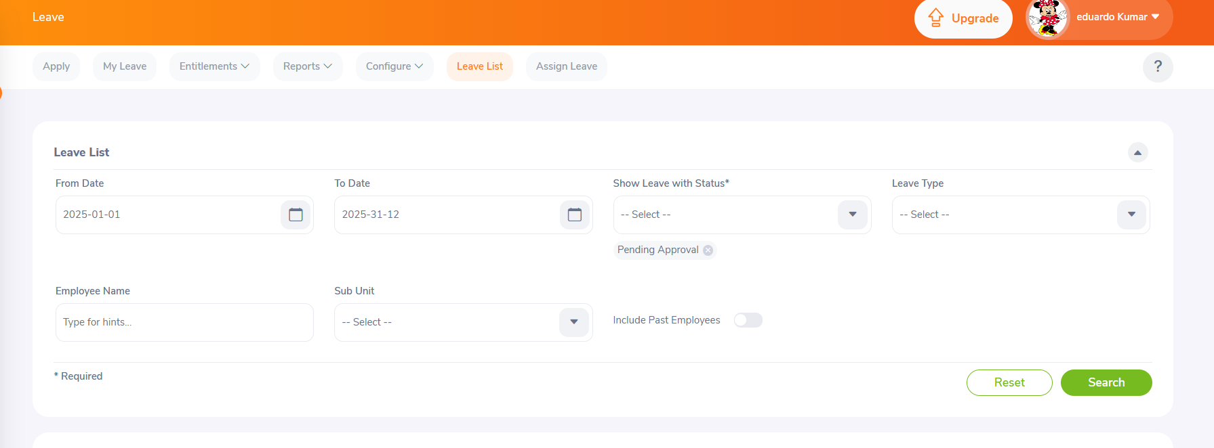

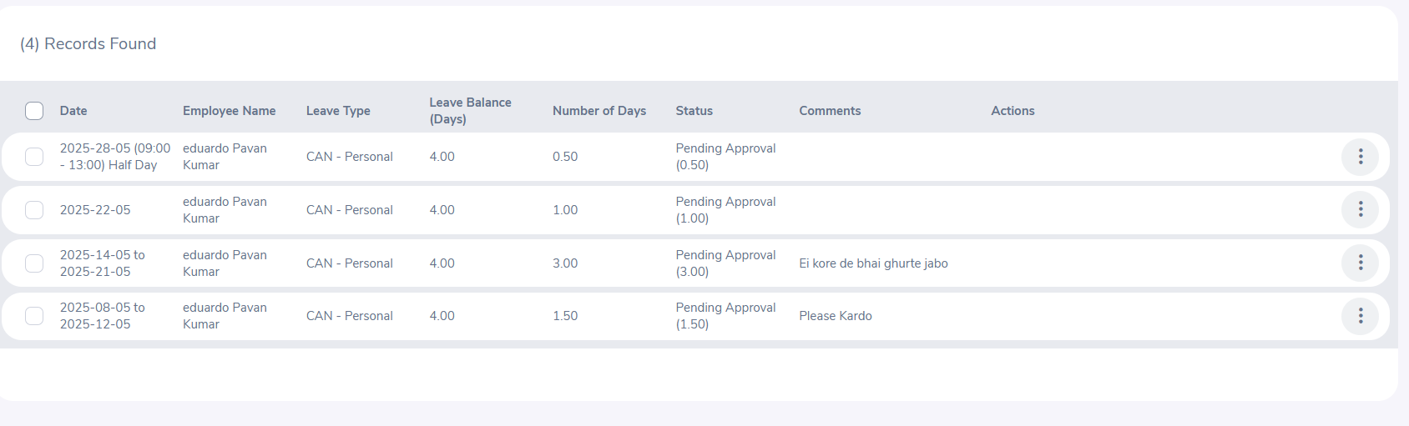

* Recruitment Module! 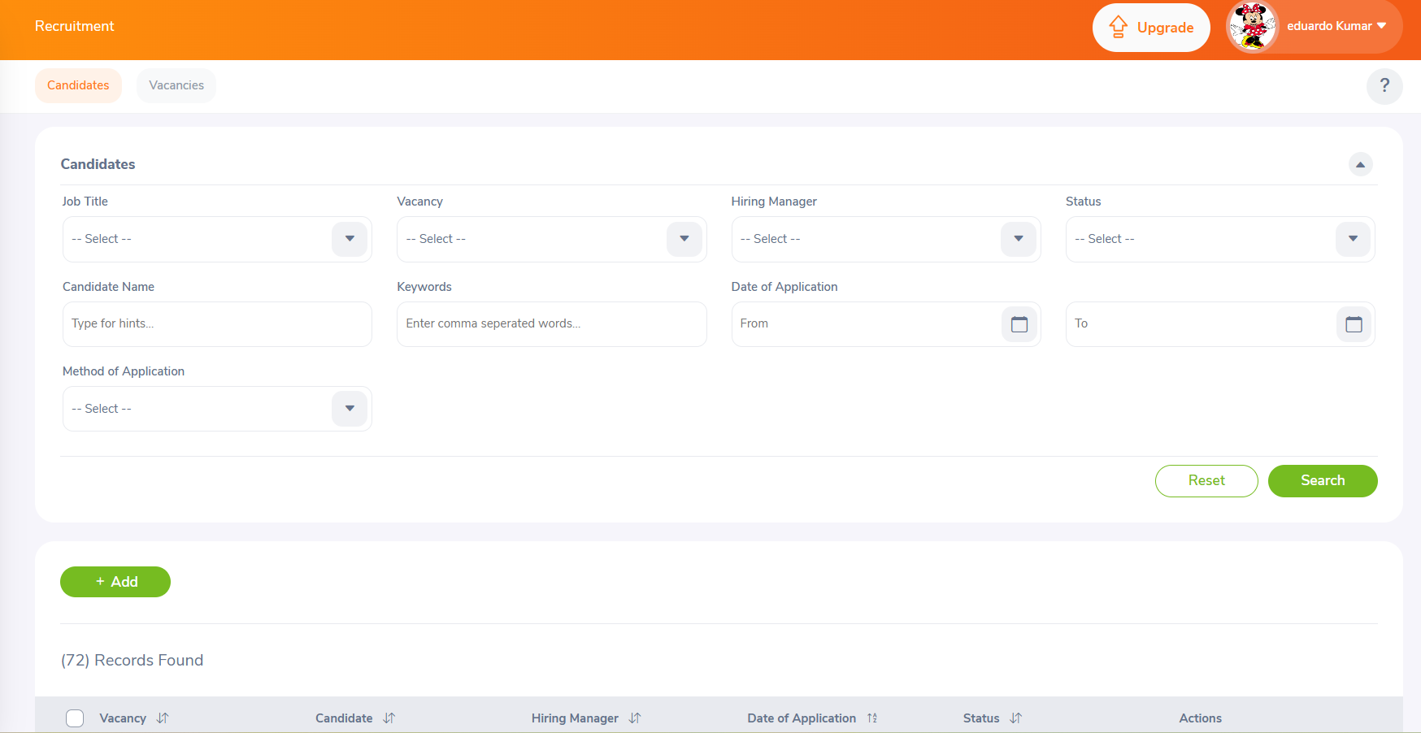
* Time Module! 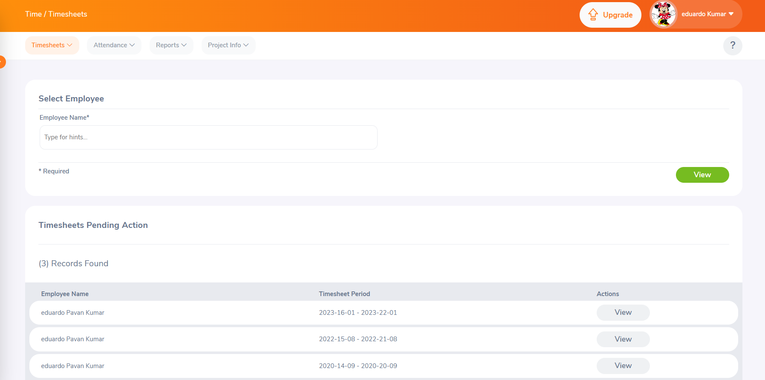
* Performance Module! 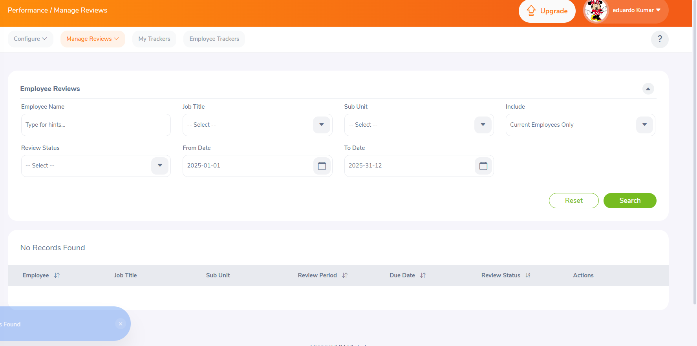

# Exclusions

* Support Widgets (External integrations not under test scope)
* Third-party Chat or CRM Modules

# Test Environments

Test URLs:

* QA: qa.orangehrm.com
* UAT: uat.orangehrm.com
* Production: orangehrm.com

Supported Platforms:

* **Windows 10/11** – Chrome, Firefox, Edge
* **macOS** – Safari, Chrome
* **Android/iOS** – Chrome/Safari mobile

Network:

* Wi-Fi, 4G

Security:

* Role-based Access
* HTTPS Authentication

Test Roles:

* Tester, Developer, Product Owner

Hardware/Software:

* Min. 8 GB RAM, Core i5 Processor
* Screen resolution 1366x768 and above

# Defect Reporting Procedure

Defect Logging:

* Identified based on requirement deviation, usability issue, crash, etc.
* Reproduction steps, screenshots, and logs must be added

Tools:

* JIRA for defect tracking

Triage:

* Severity and Priority tagging

POCs:

* Frontend: Riya
* Backend: Arjun
* DevOps: Meera

Communication:

* Daily status email
* Slack/Teams for discussions

Metrics:

* Defect count, average resolution time, reopen rate

# Test Strategy

**Step 1** – Create Test Scenarios and Cases

Test Design Techniques:

* Equivalence Class Partitioning
* Boundary Value Analysis
* Decision Table
* Use Case
* Error Guessing / Exploratory

**Step 2** – Execution Procedure

* Smoke Testing for build validation
* If passed, proceed to detailed functional testing
* Parallel testing on all supported environments

**Step 3** – Best Practices

* Shift Left Testing
* Exploratory Testing
* End-to-End Flow Testing
* Context-Driven Testing

# Test Schedule

|  |  |
| --- | --- |
| **Task** | **Dates** |
| Test Plan Creation | 7th May 2025 |
| Test Case Design | 7th May 2025 |
| Test Execution | 8th May 2025 |
| Test Summary Report | 8th May 2025 |

**Duration:** 2 Sprints

# Test Deliverables

* Test Plan Document
* Test Scenarios & Cases
* Execution Report
* Defect Reports
* Final Test Summary Report

# Entry and Exit Criteria

**Requirement Analysis**

* Entry: Requirements received
* Exit: Requirements reviewed & understood

**Test Execution**

* Entry: Signed-off test cases, stable build
* Exit: Defect & execution reports ready

**Test Closure**

* Entry: Execution complete, final reports ready
* Exit: Final sign-off

# Tools

* JIRA – Bug Tracking
* XMind – Mind Mapping
* Snipping Tool – Screenshots
* MS Word/Excel – Documentation

# Risks and Mitigations

|  |  |
| --- | --- |
| **Risk** | **Mitigation** |
| Tester unavailability | Backup resource plan |
| Build not deployable | Focus on test documentation and automation |
| Time constraints | Extend hours / Add more testers temporarily |

# Approvals

Documents needing approval:

* Test Plan
* Test Cases
* Test Reports

Approval Required Before:

* Proceeding to next test phase
* Final closure of testing